***Admin Portal architecture***

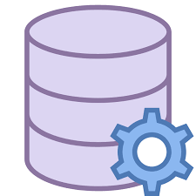

Retrieve statistics

View graphs

View report

Confirmation message for adding /deleting plumber

Storage

Decryption using hashing and salting . Hashing algorithm is sha 256.

Password encryption using hashing and salting . Hashing algorithm is sha 256.

Database

Queries send via api

Query database

Add New case

Close Case

Generate report

Add and delete plumber

***Mobile app architecture***



Decryption using hashing and salting . Hashing algorithm is sha 256.

Confirmation message after final submission of data

Queries send via api

Password encryption using hashing and salting . Hashing algorithm is sha 256.

Storage

Database

Query database

Scan barcode

Upload images

Fill in geyser details